Elements of a Messaging System

1. 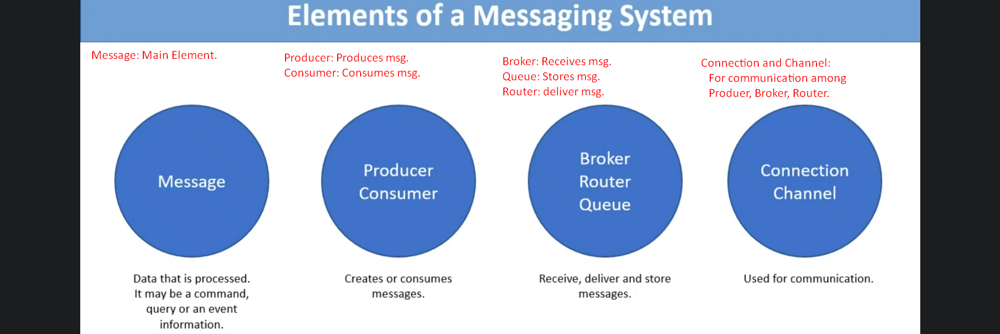Message:
   1. Message is the main element.
   2. It may be a
      1. Command
      2. Query
      3. E-mail.
2. **Producer**:
   1. Creates message.
3. **Consumer**:
   1. Consumes Message.
4. **Broker**:
   1. Receives message.
5. **Queue**:
   1. Stores message
6. **Router**:
   1. Deliver message
7. **Connection & Channel**:
   1. Used for communication b/w producer, broker, consumer.
   2. Producer, Broker, Consumer corresponds to Shipper, Broker and Carrier in Logistics.
8. 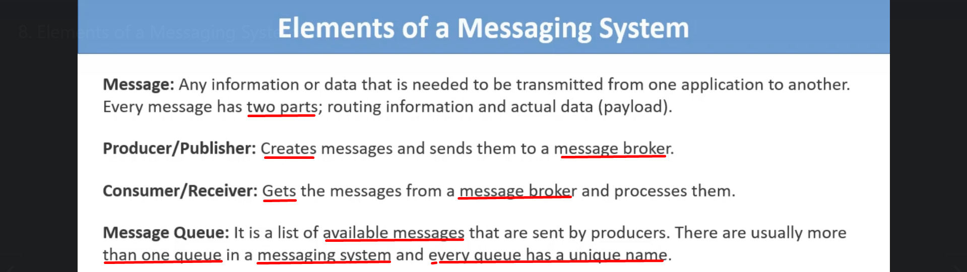
9. 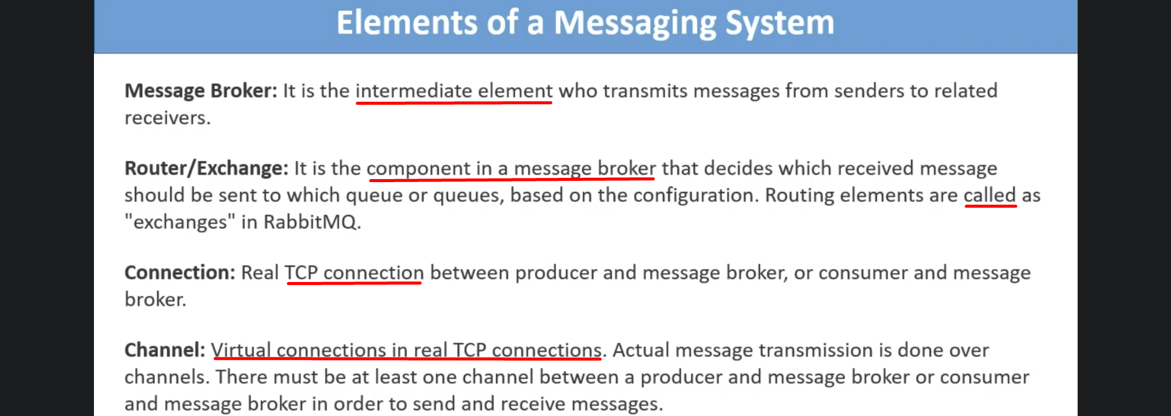
10. 